SDCC PHOTO DEPT  Advertising Photography: Photo 230  N. David King, Instructor |  | NAME:________________________________
 |  | DUE: Grade:_______

PHOTO PROJECT
" Large Product: Automotive "
A car dealership devoted to high quality new and used vehicles has decided to purchase the cover page of the local auto trader and feature one of its nicest cars on each cover. They have also arranged to do a feature each month on the selected car similar to any automotive magazine’s article. They want to show the cars in some location that shows off not only the car but creates a “life style” attitude to the shot as well. Your job is to shoot the very first of their covers.

Subject | An automobile. It can be any sort or vintage of automobile but remember this car is being sold and is illustrated as an special example of its type. You need to place the vehicle in a location designed to show off its nature and also to achieve the life-style approach of making the viewer want to be seen in this car and at that place. Inside will be a feature on that car also showing some details of it.
Materials/Needs | Camera, meter, tripod. You may shoot either film or digital. You will likely need some help (so team up) along with additional lighting devices such as reflectors and possible portable flash.
Procedure | Shoot in Color. You can use either digital or film.  Really analyze angles and lenses to chose the correct view to accentuate the car’s positive design and play down any problems with it. You may use a model with the car if you wish.  Make the best possible 8x10 or 8 ½ x 11 print of YOUR CHOICE for the cover and mount that on an 11x14 board.
To Turn-in | In an 11x14 envelope, turn in…  - This project sheet.  - Contact prints with appropriate data  - make 1 8x10 / 8.5 x 11 print mounted on 11x14 board  - Optional: create “sell-sheet” layout of main and ancillary shots.  In class be prepared to discuss why you chose the shot you did and what it says about the subject.
Grading | Grading will be based on how well you used the shooting, composition, lighting, and printing techniques to best convey your stated “image” or “look” for the subject and also the sheer technical quality of the images and presentation.

MEMORANDUM

Date: 09/15/08

From: N. David King, Asst.. Professor, San Diego City College Photo Department

To: Owner of the subject Vehicle

Subject: Photographs of your Vehicle

Dear Sir or Madam:

The other side of this form contains the assignment instructions to the student/bearer of this document. As an assignment for a the Photo 230 Class in Advertising Photography they are required to select and photograph a special vehicle as a simulated cover shot and feature article. This work is not being done for hire, for sale, or for any other commercial purpose (however the student is free to make any arrangements with you for use of prints apart from class participation and display).

I would very much appreciate your cooperating with them to allow them access to photograph your vehicle. Please understand, your cooperation is completely voluntary and you are in no way required or even being asked to cooperate against your own judgment.

The students in this class have been cautioned about interfering with business activities or access to locaton facilities and have been told they are to obey any restrictions you may place on their activities and/or access or that they will be directly accountable to you or the authorities. They are also aware that they are personally responsible for their activities and that neither the school nor school staff/faculty is in any way to be held liable. They are not acting in the capacity of agent or representative of the school in any manner whatsoever. The student presenting this is simply attempting to complete a class assignment.

If you wish to verify that this is a legitimate class assignment you may contact me in the following ways:

Email: dking@sdccd.edu

Feel free to copy this for your records but please return the original to the student since they must turn it in with their completed assignment. Thank you very much for your help and cooperation.

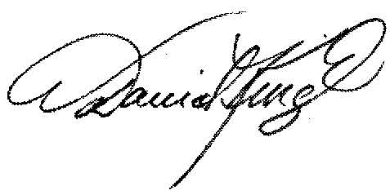
N. David King

