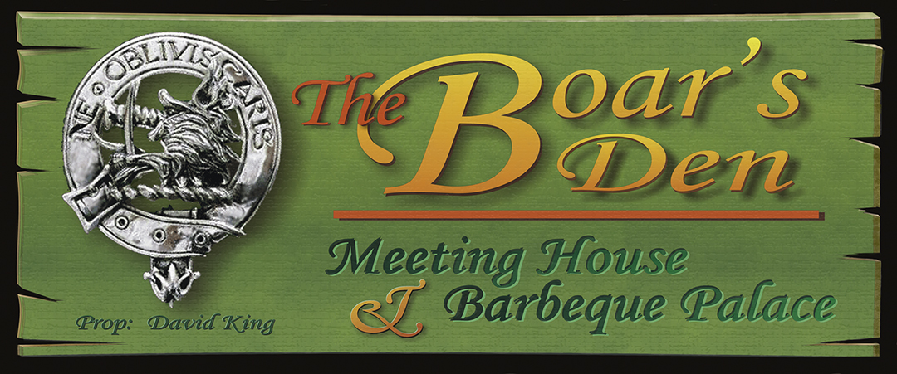

Smokin’ Recipes from the Boar’s Den

Big House Brisket

Briskets are the mainstay of Texas Barbeque and smoked brisket is considered an art form down there. This version comes from my first experiment with it. In addition to experimenting with the brisket itself, I also tried some new seasoning I acquired with my friend Julie on a trip to the Temecula Olive Oil Company (TOOC). The Brisket was a 6.8 lb full brisket from the local supermarket.

RUB:

The rub was made from the following ingredients:
- McKormick Meat Marinade (1 pkt)
- TOOC Spicy BBQ Rub (a heaping tablespoon)
- Crushed red peppers ( a tablespoon)

Then to taste…

- Sage
- Cumin
- Oregano
- Thyme
- Garlic Powder

The ingredients were thoroughly mixed in a bowl and then a portion of it (about ¼) was hand rubbed over the meat. The meat was covered in Cellophane and put in the Refrigerator for an hour

MOP SAUCE:

To the remaining rub seasoning was added about ¼ cup of TOOC Roasted Garlic Olive Oil, 1/8 cup each of soy sauce, Worcester Sauce, and Kitchen Bouquet and ¾ cup Big House Red California Wine. These were mixed in thoroughly and reduced a little on a low burner to thoroughly blend the spices then set overnight in the refrigerator. When cooking time approached the amount was brought back up to about a cup and a half with more wine and oil and heated.

Heating allows it to penetrate better, the oil mimics the fat in the meat to keep it moist and the acids in the wine help tenderize the meat. The spices add flavoring to the “bark” formed by the rub.

WOOD:

I used pecan as the primary fire logs with additional soaked Hickory chunks and some lemon wood I pruned from my tree for rich smoke. The blending of the woods adds a complex but fairly mellow flavor to the meat.

I used a few charcoal briquets to help initially ignite the logs but then for the smoking process used hardwood chunk charcoal instead of briquets for the main heat as it burns hotter and longer requiring less fuel and has a much cleaner taste.

PROCESS:

A initial charge of charcoal is used to ignite the logs and the first load of hardwood chunk charcoal. The vents are opened and the cooking chamber allowed to reach 200-225.

When temp is reached I put in the first charge of soaked chips/chunks and place the roast on the grill slightly to the left of center. On the right hand side of the grill, right over the opening into the heating chamber I place a shallow pan of water to add some steam for moisturizing and helping to keep the meat from drying out. I give the brisket a good mopping of sauce, close down the inlet vent about halfway and start it smoking.

During the first 30 minutes I stabilize the vents to create a constant heat of about 200-225 in the smoking chamber. However it needs enough draft to keep moving and swirling the smoke over the meat and not letting it settle on it for long to impart any creosote or particulates that will make the meat bitter. About every30- 45 minutes I give it a quick mopping (trying to keep the chamber open for the shortest possible time) and check the fire and the smokestack for any needed elements: fuel, wet chips/chunks, etc. I try to not let the surface dry out.

When the center of the meat almost reached 185°F I pulled it out of the chamber, wrap it in foil and put it in a preheated microwave (I use a wet towel to preheat the microwave) to rest for 15-20 minutes or so and redistribute the juices throughout the meat. By putting it in a prewarmed space (a prewarmed cooler would work too) it stays warm without further cooking apart from what it does during the resting period anyway. I will take a damp towel and heat it in the microwave. That create a warm AND moist environment. This is a really important step. It redistributes the juices.

While it is resting I make a gravy-like sauce using the remainder of the mop sauce as seasoning along with some Bulls-Eye Hickory BBQ Sauce. This can be drizzled over the slices or served in a gravy boat for individual use. It definitely adds a solid BBQ flavor to the meat.

Slice across the grain into desired thicknesses (I usually try to cut about ¼ inch slices) and cut away the fat from the middle. It was a most satisfactory experiment!

