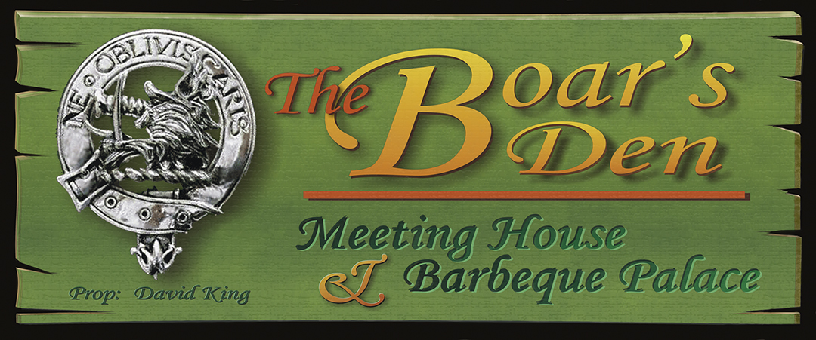

Smokin’ Recipes from the Boar’s Den

Pinot Pork Loin

Pork Loin is responsible for my getting into smoking meat in the first place. I had done them over indirect heat on a barbeque and it seemed a natural to try to cook slowly with smoke. Oh yeah! The following recipe was for a 4.3 lb roast from Costco that was frozen. It was a wonderful cut of meat, something called a “double loin” that was rolled and tied.

RUB:

The rub was made from the following ingredients:
- “ “ Rub
- Chimayo ground red chili pepper (a teaspoon)
- Crushed red peppers ( a teaspoon)

Then to taste…

- Sage
- Cumin
- Oregano
- Thyme
- Garlic Powder
- Onion Salt
- Salt
- Black Pepper

The ingredients were thoroughly mixed in a bowl and then a portion of it (about ¼) was hand rubbed over the meat. The meat was covered in Cellophane and put in the Refrigerator about a day in advance.

MOP SAUCE:

To the remaining rub seasoning was added about ¼ cup of olive oil, 1/8 cup each of soy sauce, and Kitchen Bouquet and ¾ cup Pinot Grigiot Wine (hence the name). These were mixed in thoroughly and reduced a little on a low burner to thoroughly blend the spices then set overnight in the refrigerator. When cooking time approached the amount was brought back up to about a cup and a half with more wine and oil and heated.

Heating allows it to penetrate better, the oil mimics the fat in the meat to keep it moist and the acids in the wine help tenderize the meat. The spices add flavoring to the “bark” formed by the rub.

WOOD:

I made the subject loin using pecan as the fire logs with additional soaked Pecan chunks and Cherry chips for rich smoke. The blending of the woods adds a complexity to the flavor. I’m also anxious to try maple as the soaked wood.

I used a few charcoal briquets to help ignite the logs but then for the smoking process used hardwood chunk charcoal instead of briquets for the main heat as it burns hotter and longer requiring less fuel and has a cleaner taste.

PROCESS:

A small amount of normal charcoal is used to ignite the logs and the first load of hardwood chunk charcoal. The vents are opened and the cooking chamber allowed to reach 200-225.

When temp is reached I put in the first charge of soaked chips/chunks and place the roast on the grill slightly to the left of center. On the right hand side of the grill, right over the opening into the heating chamber I place a shallow pan of water to add some steam for moisturizing and helping to keep the meat from drying out. I give the roast a good mopping of sauce, close down the vents and start it smoking.

During the first 30 minutes I stabilize the vents to create a constant heat of about 200-225 in the smoking chamber. However it needs enough draft to keep moving and swirling the smoke over the meat and not letting it settle on it for long to impart any creosote or particulates that will make the meat bitter. About every30- 45 minutes I give it a quick mopping (trying to keep the chamber open for the shortest possible time) and check the fire and the smokestack for any needed elements: fuel, wet chips/chunks, etc.

When the center of the meat almost reaches 135°F) I pull it out of the chamber, wrap it in foil and put it in a preheated microwave (I use a wet towel to preheat the microwave) to rest for 15-20 minutes or so and redistribute the juices throughout the meat. By putting it in a prewarmed space (a prewarmed cooler would work too) it stays warm without further cooking apart from what it does during the resting period anyway. This is a really important step. It redistributes the juices, brings the center to little more than medium. (I know modern pork is safer but old habits still make me want to cook it a little more than beef.)

While it is resting I make a gravy-like sauce using the remainder of the mop sauce as seasoning added to a basic roué of butter and milk to thicken it. This can be drizzled over the slices or served in a gravy boat for individual use. It definitely adds a tangy flavor to the meat and is great on potatoes as well.

Cut and pull away the strings, slice into desired thicknesses (I usually try to cut about ½ inch slices).

