Creating 3D Anaglyphs
By N. David King

(This material is extracted from the book
“Practical 3D Photography” by N. David King)

3D photographs start with 2 captured images called “stereo pairs.” This simulates the way we see three dimension naturally because we actually perceive the world from two vantage points. Our eyes are fixed in the distance between them so we actually doi not truly perceive 3D for a great distance. But by varying that distance between shots we can create dimensionality actually greater or more exaggerated than we see it. The guidelines are, at 10 feet the distance should be 2.5-3 inches. For every ten feet further, add about 4 inches to the separation. Both shots need to be exactly level and on the same plane from the ground. Once you have the two shots, then here is how to process them into an anaglyph.

Step | Action | Result/Notes
1 | Create a new file with the following characteristics:  - The canvas size should be at least 50-70 pixels taller and 100 pixels wider than the stereo image files to give you room for alignment. (Excess will be cropped later.)  - The resolution should be the printing resolution that was set for the stereo image files.  - The “contents” field should be set to “transparent.” | This will become your final file so you might want to name it with the final image name.  I’d recommend saving this file as your 3D master then, you can change profiles for various output devices and save them as output-specific masters.  You now have three files open on the desktop.
2 | Select the right-hand image and click on it to make it active
3 | Go to Image AdjustmentsLevels | This opens the “Levels” dialog box.
4 | In the “Channel” field, select “Red”
5 | Below the histogram are two fields for the “output” levels. It will read “0” in the left box and “255” in the right box. Select the right hand box and change it to “0” (Zero) | This will remove all of the red channel information from the image and leave it looking very cyan in color.

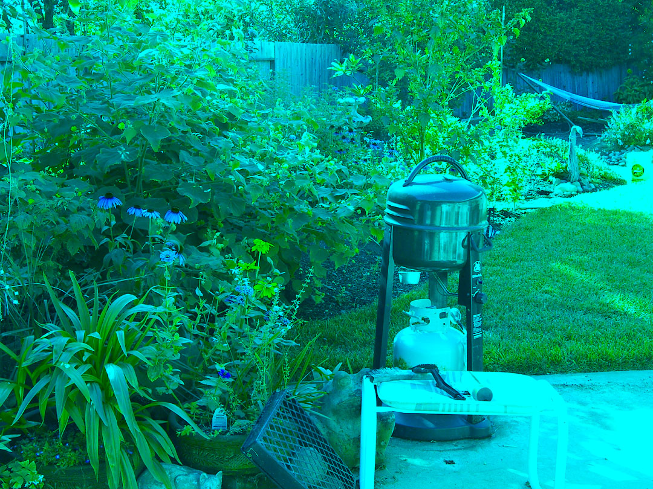
The Cyan (Right) Frame

6 | Go to SelectAll | The selection marque will surround the entire image.
7 | Use Cntl/Cmd C to copy the file to the clipboard
8 | Click on the new file to make it active.
9 | Use Ctrl/Cmd V to paste the right hand (cyan) file into the new file as a layer. | You will have the image floating in the middle of the new file.
10 | Click on the left hand image to make it the active image.
11 | Go to Image AdjustmentsLevels | This opens the “Levels” dialog box.
12 | In the Channel field select ‘Green’
13 | Below the histogram are two fields for the “output” levels. It will read “0” in the left box and “255” in the right box. Select the right hand box and change it to “0” (Zero) | This will remove all of the green channel information from the image and leave it looking very majenta in color

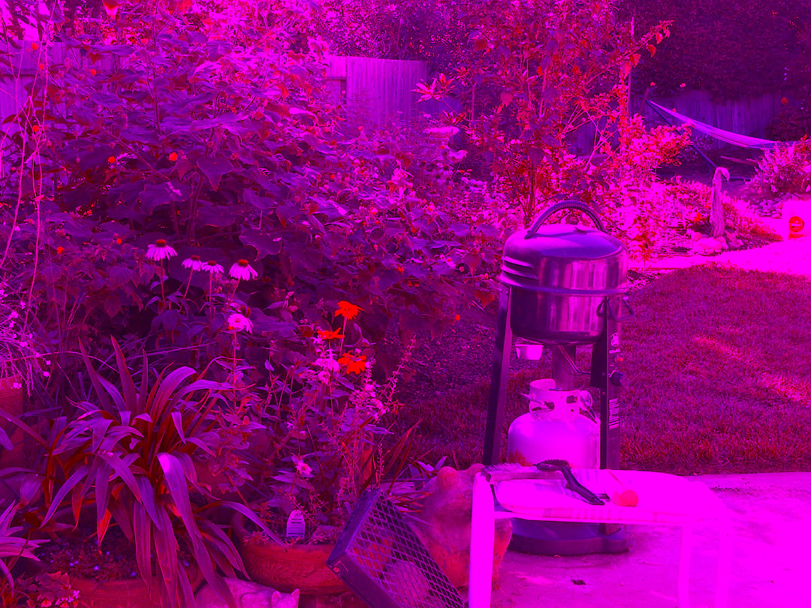
Left hand frame with Green removed

14 | In the Channel field now select ‘Blue’
15 | Below the histogram are two fields for the “output” levels. It will read “0” in the left box and “255” in the right box. Select the right hand box and change it to “0” (Zero) | This will remove all of the blue channel information from the image and leave it looking very red in color

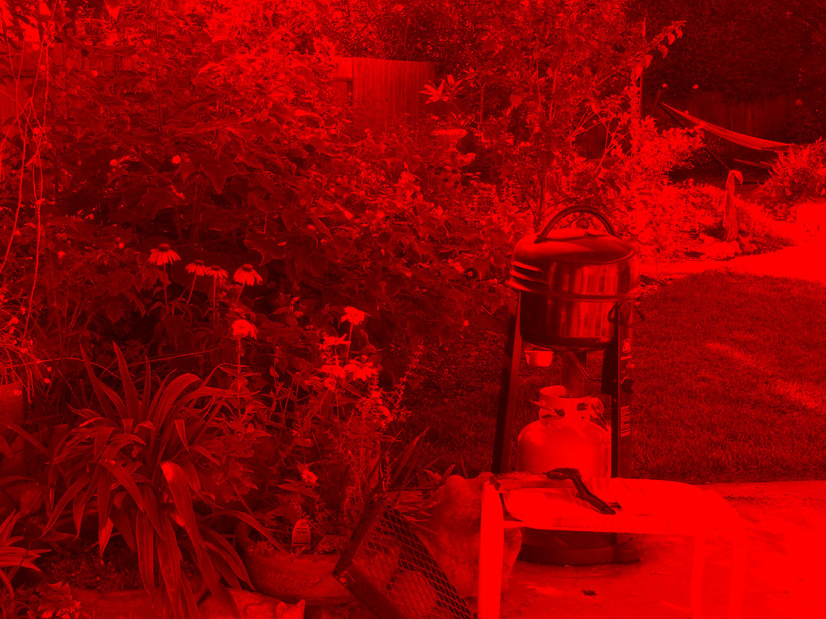
Left hand frame with both green then blue removed

16 | Go to SelectAll | The file will be surrounded by the marque lines
17 | Use Cntl/Cmd C to copy the file to the clipboard
18 | Click on the new file to make it active.
19 | Use Ctrl/Cmd V to paste the left hand (red) file onto the new file as a layer. | This will add a new layer with the red image on the top
20 | Use LayerLayer StyleBlending Options | This opens the blending options dialog.
21 | Set the blending option to “Screen” | You will now see both images but where the red and cyan layers overlap the color will be accurate.

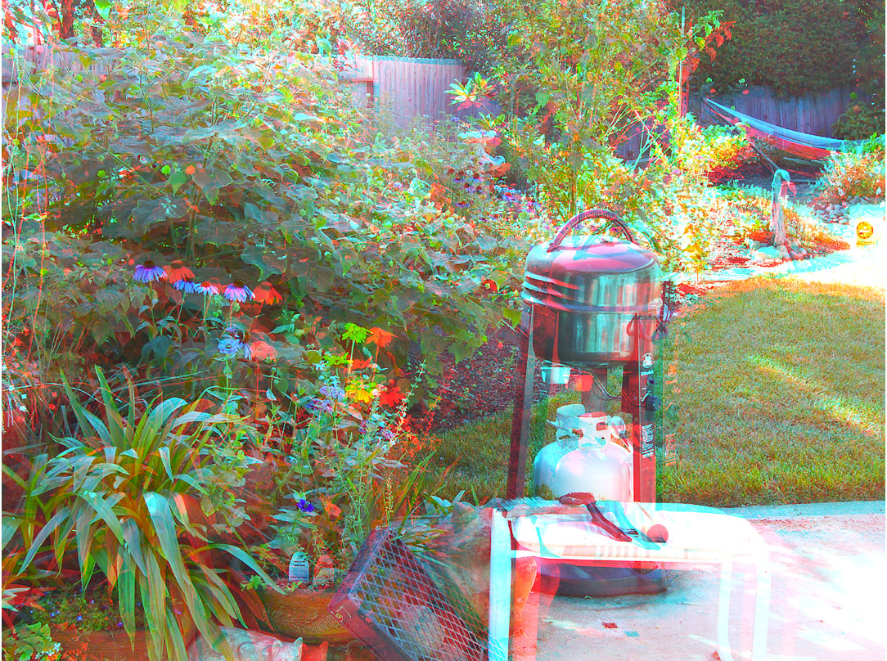
Left and right frames as layers using “screen” as the blend mode

22 | Use the move tool on the top red layer to align the layers. Zoom in and align the area you want to be the “surface” or the focal point if you shot with that approach.  For this example I chose the vents on the barbeque to be at my surface plane so overlapped them to match as perfectly as possible.  I find this easier to do without the viewing glasses so I can clearly see the two images. A light spot is the easiest to see.  Zoom out to check it with the viewer then zoom back in and adjust as necessary. | Areas in front of the “surface” item will appear to come toward the viewer from the image and those behind will appear to recede behind the photo.  If you are doing a portrait, this generally should be the eyes of the subject. For products it is often the label or name on the front of the product.
23 | Close, but DO NOT SAVE the left and right files or you will overwrite the originals with these copies that have the color channels dropped.
24 | Zoom out to see the entire image and crop the parts hanging out from the combined image that were created when you re-aligned the layers in the last step. | If you leveled your tripod there will be very little extra on top and bottom.

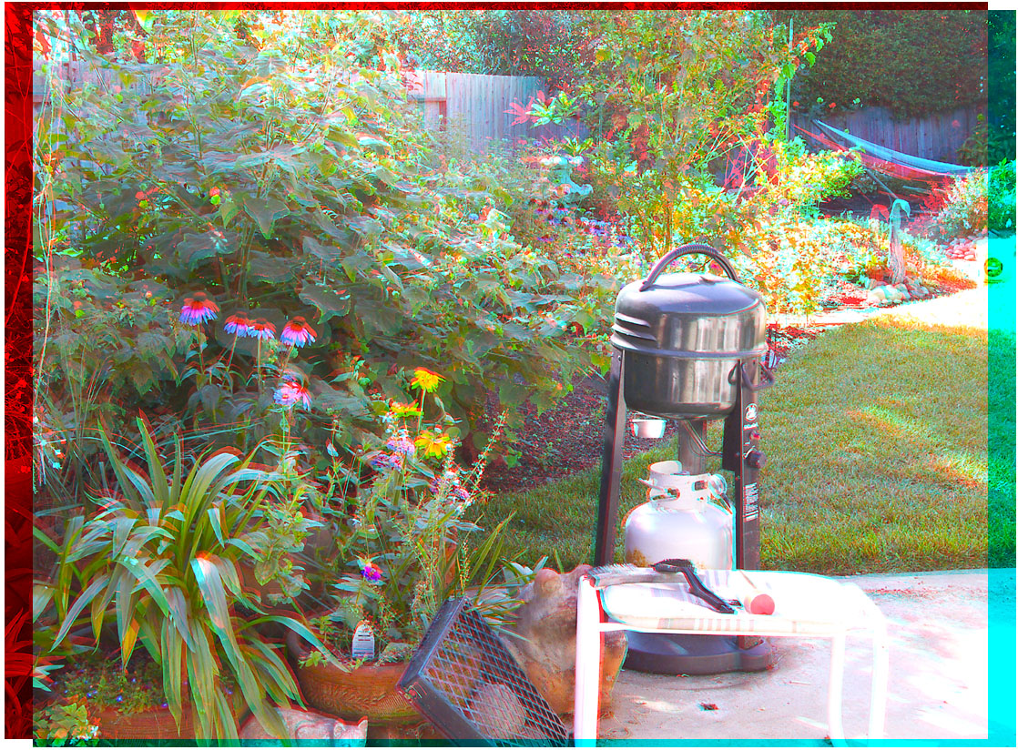
Left and right frames aligned on barbeque vents to establish the “surface”

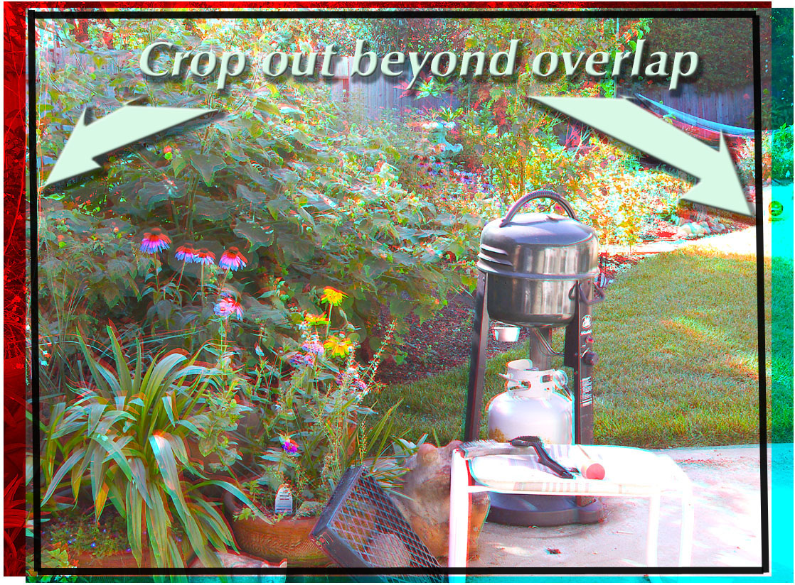
Aligned frames showing crop lines to isolate the overlapped areas.

25 | Save that puppy as your Master 3D file.

And here, so you can see it more clearly is a slightly larger print of the cropped 3D photo of the view out my window (you’ll need to use your 3D red/cyan viewer or glasses to see the 3D effect.

