Simulating an Old Color Photo
N. David King

It’s funny, but sometimes when the techy world seems overwhelming there is a backlash and people grow nostalgic for the old days and the look of those old days. Old approaches are revisited, bad lenses, cheap cameras, soft and distorted images all start to appear and be treated as if they were being seen for the first time. And sometimes that is true. But aging a film-based photograph is something that takes time for the dyes to fade the colors, the surface scratches to appear, so here is a faster way to achieve that look using Photoshop™.

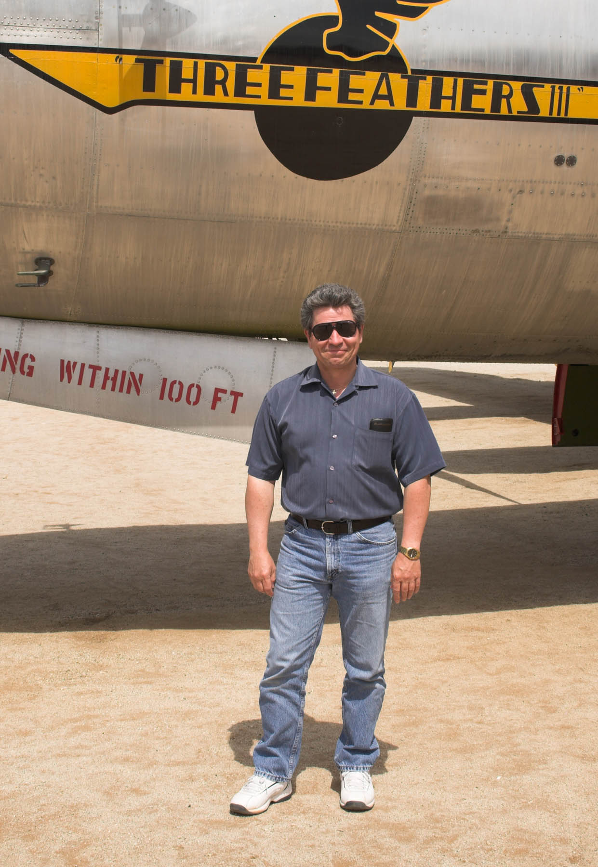
Remember, a lot of factors contribute to the aging of a photo and consequently the look of one aged photo may be different than the look of another one that had different chemical makeup and different storage issues. Each of the steps in the following process can be varied to suit the intended need. You might, as done here, alter the discoloration to represent a Kodak photo stored in a cardboard shoebox or apply a different color fade to represent a photo hung on the wall for decades or simulate various qualities of snapshot camera lenses.. But most of those variations can be achieved by modifying these steps. And once you have done it and played with variations, you can add other steps to suit your own needs.

The approach looks best on a photo that looks like it might have been taken way back then, for example something that looks like a travel or family snapshot. For this handout I’ve used a shot taken when a historian friend visited the Air Force Museum at March Field and wanted a shot of himself next to a plane that he was writing about. First, here is the original photograph without any work done to it. If only he had a uniform on we could make this look like it was taken back when the B-29 in the picture was flying missions in the Pacific.

Oh well, here we go…

Step | Action | Result/Remarks
1 | Create a Duplicate Layer and lower the saturation. | Some photos fade unevenly depending on how they are stored or displayed. You could subtly erase through to the original in patches using a very soft brush at 10%-15% opacity to simulate that uneven aging effect.
2 | Create a New blank Layer and fill it with a sepia tone (a reddish brown). Set the blending mode to “Soft Light” and adjust opacity to taste. | I’ve used this layer at a high opacity to better show off the effect. You can play with the specific color for other fading effects.

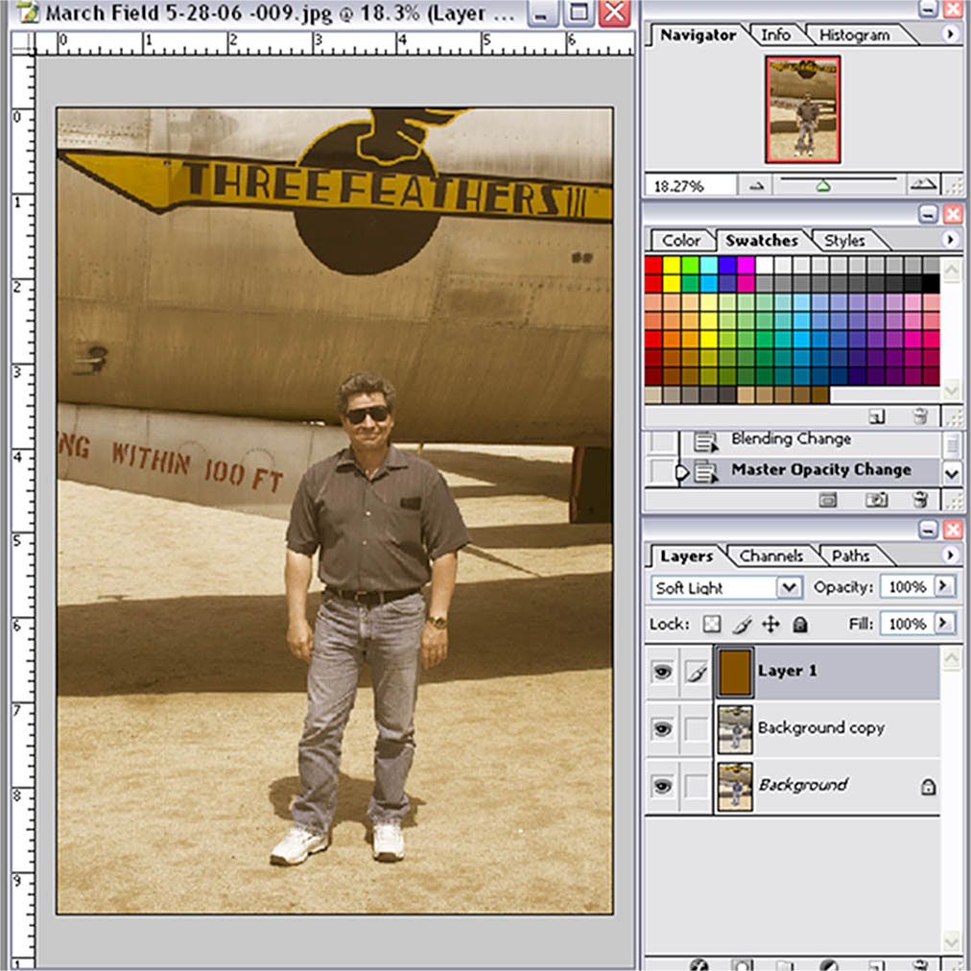

3 | Merge these top two layers (the sepia fill and the desaturated layer.) | Using the layer mask you can blend unevenly to simulated uneven fading.
4 | Duplicate the top (newly merged) layer.
5 | On the 2nd layer, lighten and blur using the Gaussian blur. Go further with the blur than your intended result. | This too is a variable that will achieve different looks depending on the intensity of your settings.
6. | Blend the top two layers to achieve a very slightly burred image with glowing edges. Try both a “Normal” and an “Overlay” blend for different glowing effects. Erase more through the edges to simulate the distortion of many older lenses. | (This is very similar to the Morton Effect described in another handout.) it is done to start the simulation of older, cheaper lenses in many of the snapshot cameras of the 30s through 50s.

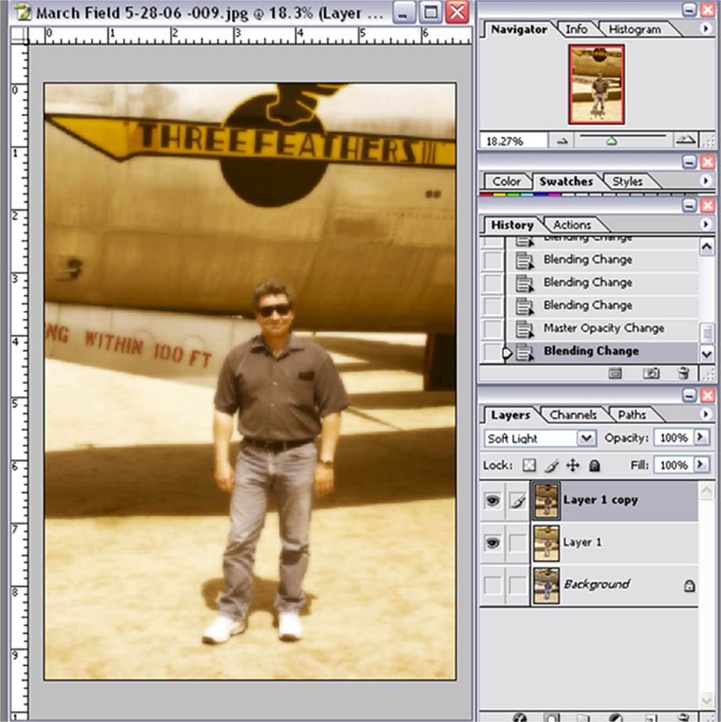

7. | Duplicate the top layer and add Gaussian (random) Noise using FilterNoiseAdd Noise | I used about 15%.

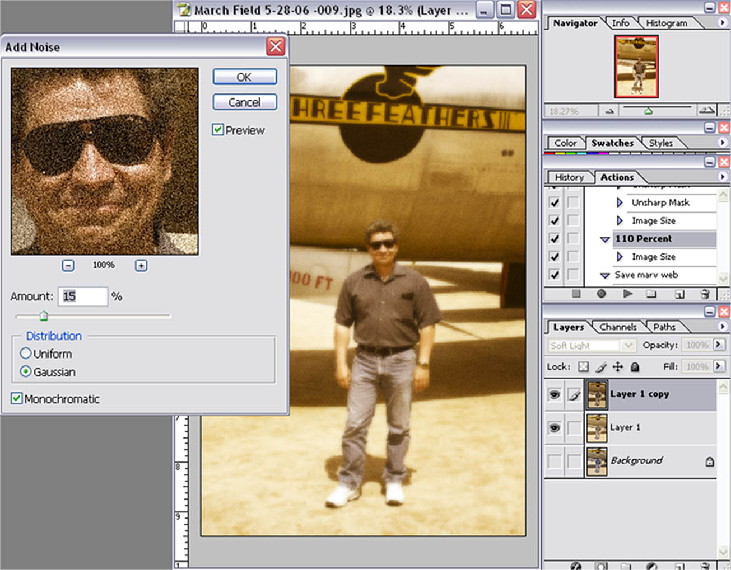

8 | Blend the top two layers using the Soft Light Blending mode | This will simulate the look of film grain. You can set the opacity of the blend to your own taste.
9. | Add a new blank layer on the top of the stack and fill it with black
10 | Apply FilterTextureGrain with the grain type set to vertical. Start with about a 70/80 setting and adjust to taste.  Set Blending Mode the “Screen.” | The grain will be white vertical streaks like scratches on old film. To make it stand out a little better on the printout of this handout I also added contrast to the layer but you probably would not need it for a good print.  You can also use a black brush on the grain layer to remove or soften some of the streaks if they are a bit overpowering.

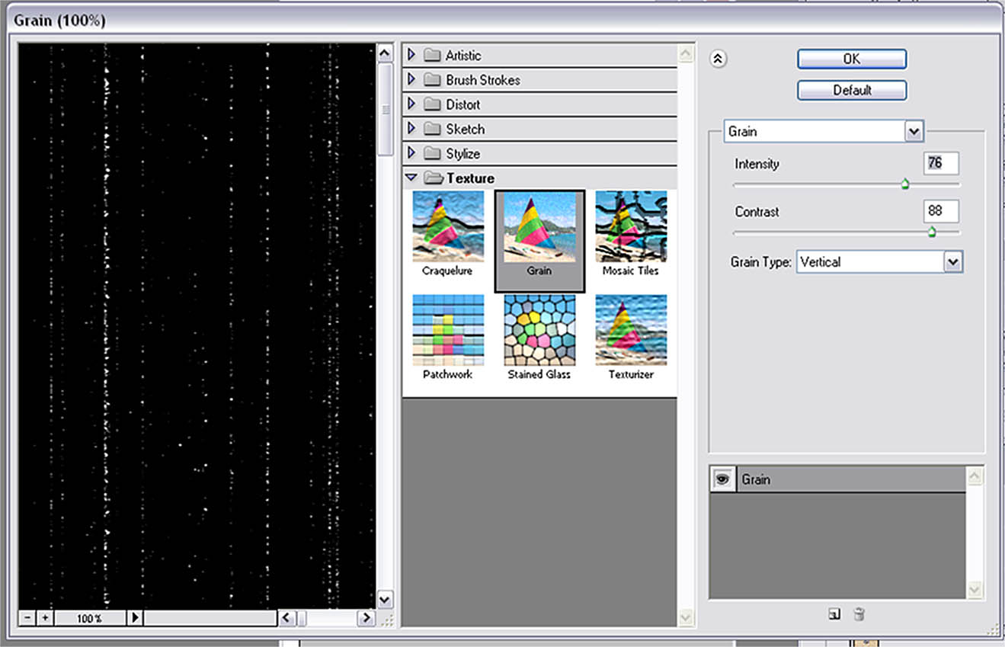

11 | Merge all but the bottom original layer
12 | Use a dark brownish black brush with soft edges set to about 10% to 15% and slowly build some darkening and vignetting along the edges and corners. | This simulates the “foxing” discoloration on photos that have been stored in wood-pulp based boxes and containers.
13 | Old photographs lose contrast so you can lower the contrast using the output sliders on the levels function to drop contrast but also allow some highlight areas to fade out using the input slider.
14 | Depending on the “look” and vintage you want you can now further desaturate the top image then selectively blend it with the bottom original for an uneven, faded look. | And there is your long stored photo from the 40s or 50s.
