Putting A Photo into Your Type Font
N. David King

Typography is an art all unto itself. Designing fonts, creating unique looks to the type on an advertising or other printed material is sometimes as important as the illustration or photo that supports the pitch in the copy and narrative. Photoshop allows you quite a bit of freedom in type layout but it is not a true vector art layout program and so has some limitations. But one thing it will let you do is create type made from a photograph. And it is pretty easy to do. Here is an example from a magazine mock-up for a self promotional portfolio piece.
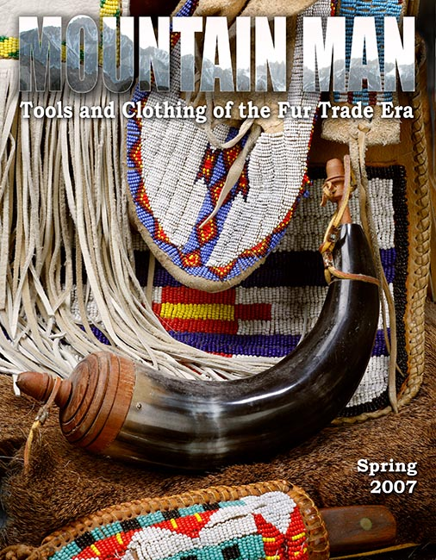
Before you start, however, you will serve yourself well to plan this out. Pre-select the images to serve as the background (it could be a blank page) and the image that is going to fill in your type. Choose the type carefully. This process works best with bold, closely spaced type. Fine lines and frilly type with fancy flourishes and fillagree does not show enough of the picture element to really see what is there. Sans Serif Type works better, generally, than seriffed faces at allowing the viewer/reader to see the photo in the type. And think about the image that will fill the type in terms of what it adds to the message or “feel” of the piece you are creating. This can be really attractive — or it can be hopelessly distracting, depending totally on your choices at this stage.

So we will start with a Photoshop workspace containing two images. The image on the right will be the “background” illustration and the image on the left will be the image that will be inserted into type and applied over the background.

Step | Action | Result / Remarks
1. | Select the Type tool from the tool bar. (The “T”) | Notice that the status line changes and you can set type parameters.
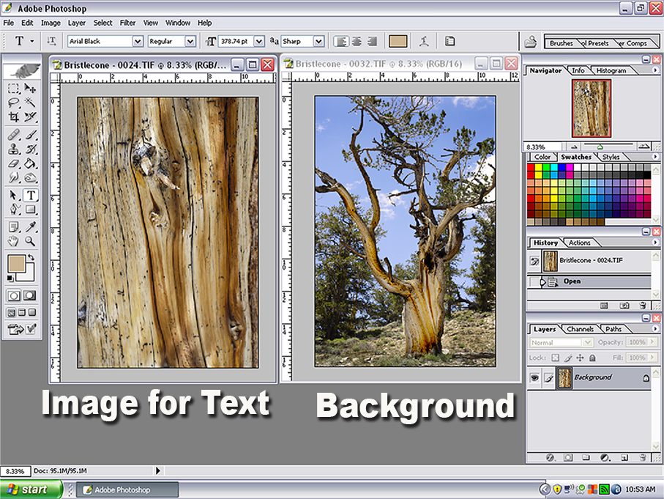
2 | Over the image that will be the type’s background, type in the title or whatever text you want. | This will open a new layer on top of the image. You can block select the type by swiping it with the cursor. When it is highlighted you can change size, color, even typeface.
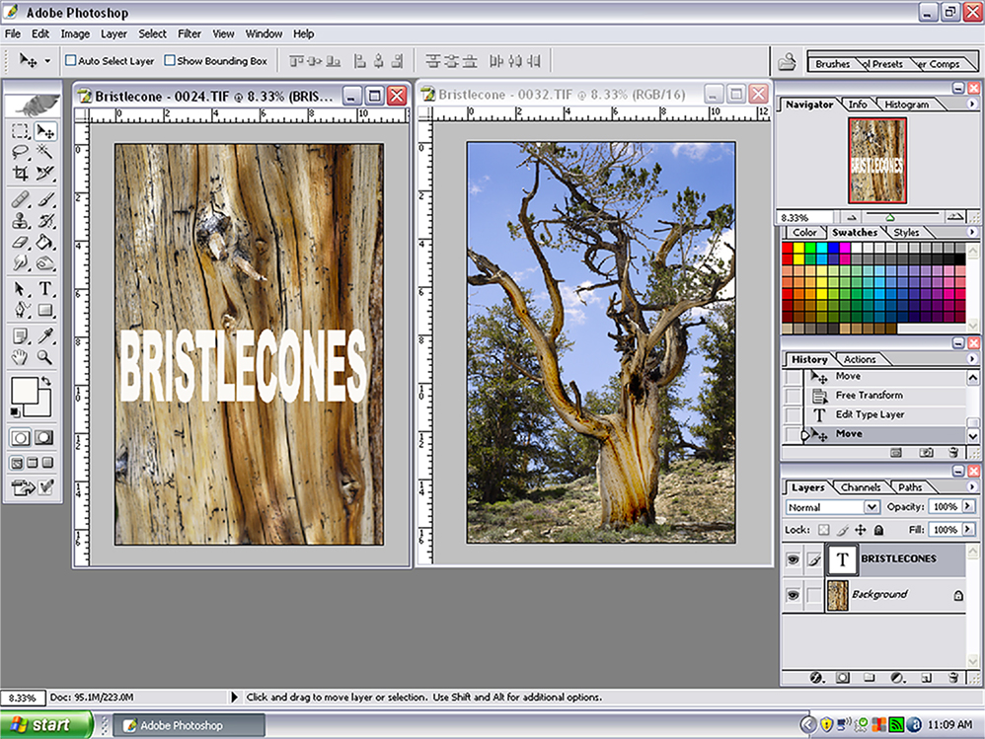
3 | When the type is the size you want it, do a color select on that layer  Select Color Select | Since the only thing on this layer is the type it is easy to select it cleanly. You will see the “marching ants” surrounding the type.
4 | Reduce the opacity of that layer to 0 (zero) percent. | The type will disappear but you can see the selection (marching ants) where it was. That means that the selection is still active although you can’t see anything from that layer.
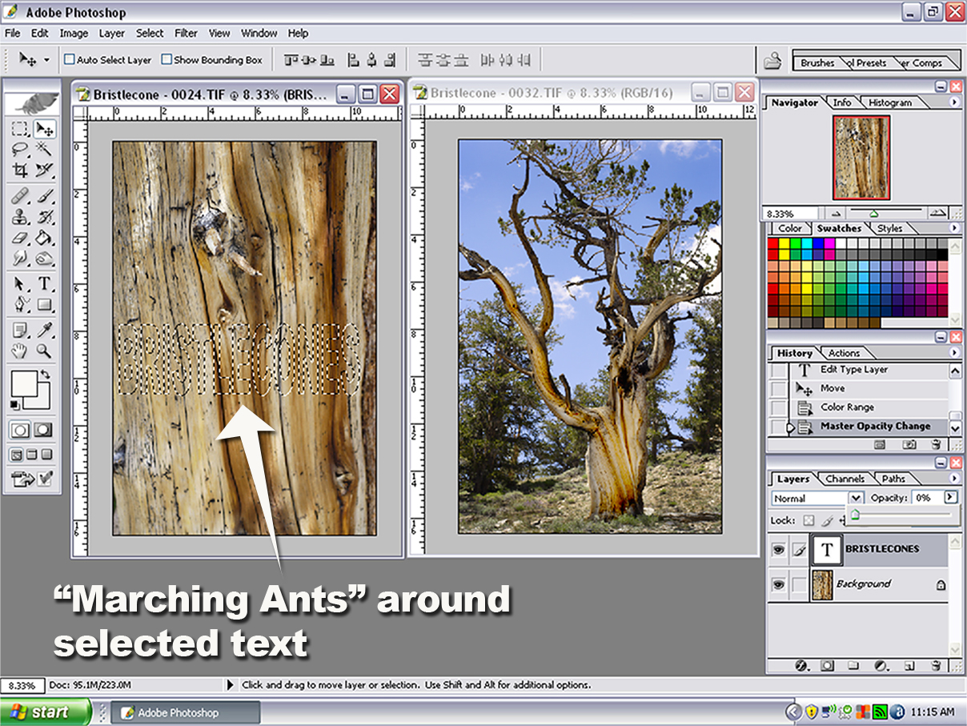
5 | Using the Move Tool. Place the type selection over the portion of the image you want to be your type. | You can still reactivate this type by selecting the type tool and swiping the text. This lets you change copy or type font and size.
6 | When the type is positioned exactly where you want it, flatten the layers.  LayersFlatten Image | The image is flattened but the selection remains in place.  The next step is the cool one!!!
7 | Click on the selection and simply drag it over on top of the background image. | This will create a new layer on the background image which contains the type selection. You can move it around and use all of the Layer Style functions (drop shadow, glow, etc.) to enhance it.
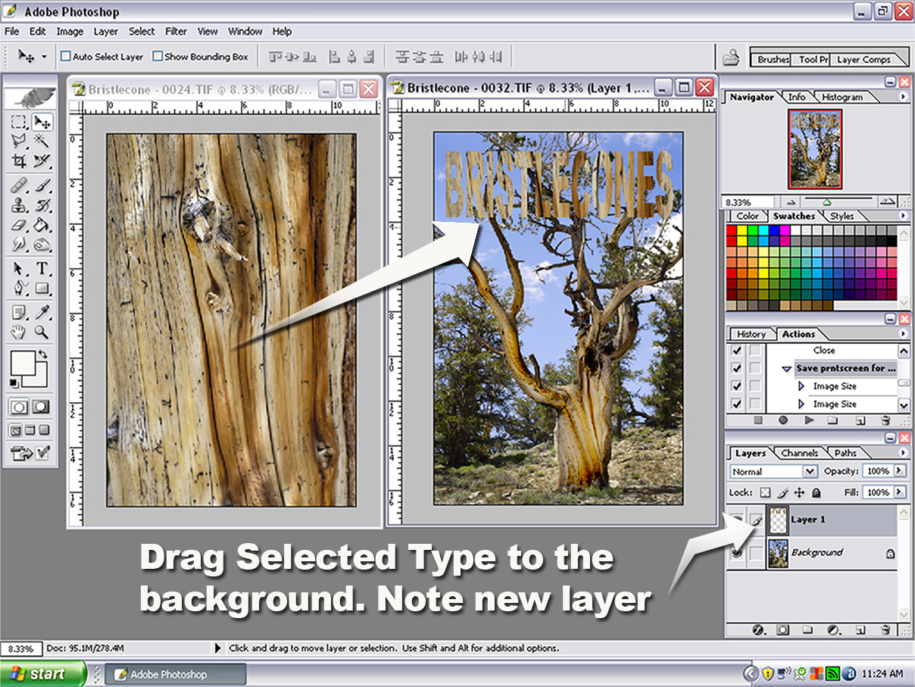
8 | While the type is on this top layer, you can move it, size it, and apply layer styles such as the drop shadow and beveled edges shown below. | All layer styles are available as is opacity, and any color or tonal editing.
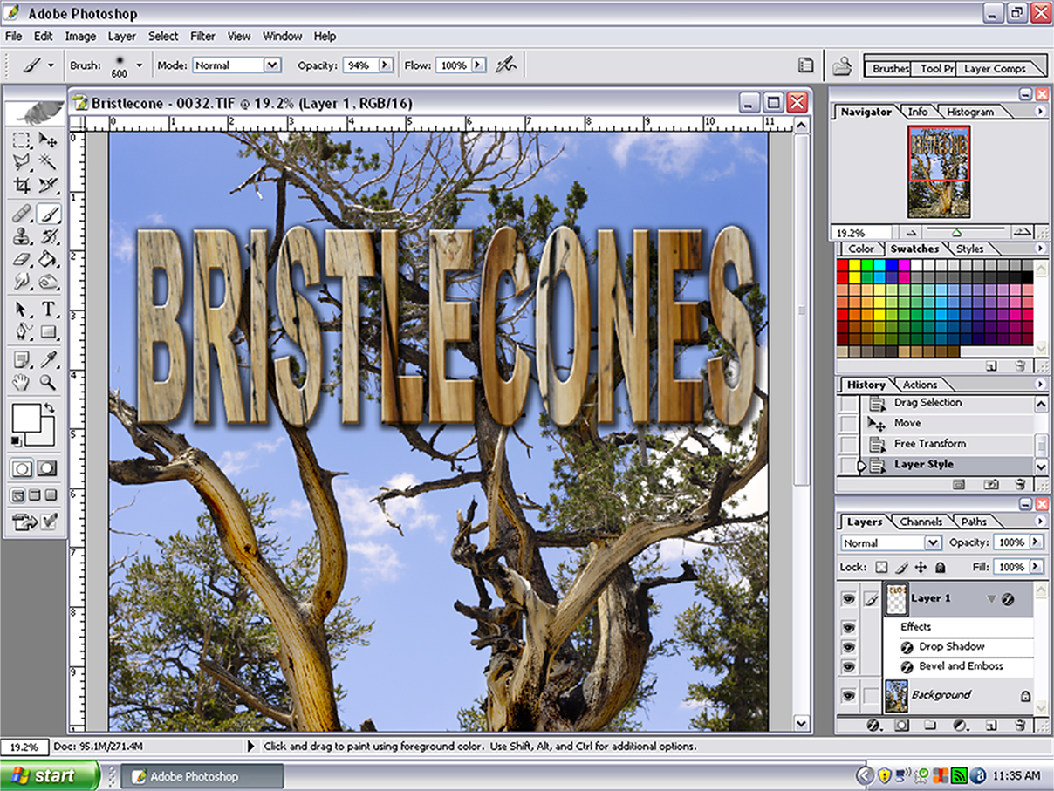
9 | When your layout is complete you can flatten the layers if needed to create your final image.

And that’s all there is to it!

