CREATING AN ACTION IN PHOTOSHOP
N. David King

If you are like most photographers there are a series of small repeatable steps you need to take from time to time that are made tedious by the sheer duplicated repetition of them. Applying standard corrections, setting file specs for output or printing, for example, are far from difficult but the half dozen steps required take time and effort in seemingly endless repetition. But Photoshop has an answer for all that: it is called “Actions.”

Photoshop’s “Actions” are simply a version of what for years and in countless applications Microsoft has called “Macros.” They are stored processes based on recording the keystrokes required to do them manually. Creating an Action is simple. Once ready, you simply do the process on a sample file while recording the input then stop the recording and save it to a file. That file can be recalled and run again in one or two key strokes and perform the function that took dozens of keystrokes before. Better still, that action can be saved to a function key where a single key stroke will set it off automatically. And, if that were not enough, using Photoshop’s “Automate” function you can assign that saved action to selected files and run it against all of them automatically.

So how is this done? Below are the precise steps required to do it.

Step | Action | Result / Notes
1 | Open a sample file that needs the work you will be saving to an “Action” | To create an action you will actually have to perform the work on a sample file. This is a very good cross check to make sure you are doing it correctly.
2 | Click on the “Actions” tab. It is located in the History Pallet window next to History Display. | This opens the Action pallet. You can see other default actions in the list already. Photoshop has a number of predefined actions and you can download others from various sources online.

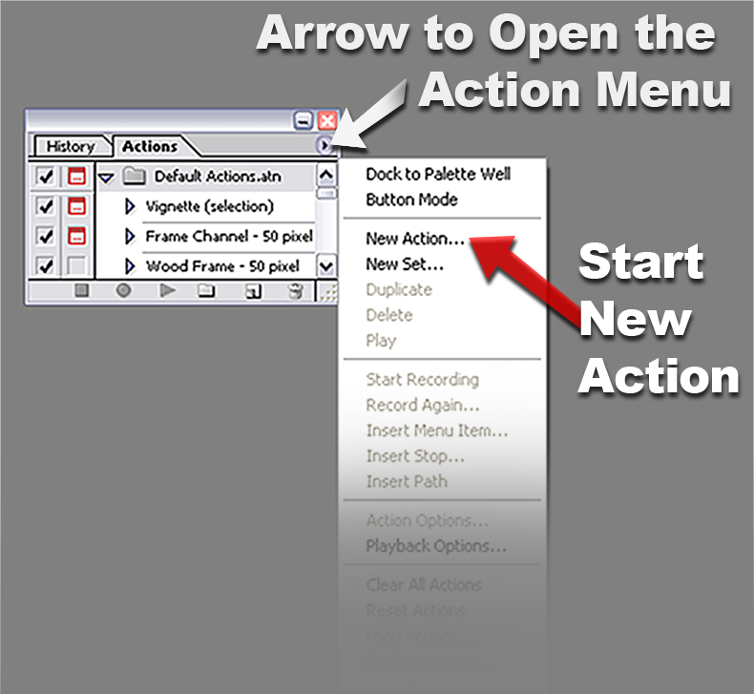

3 | Click on the arrow at the top right of the pallet to open the Actions menu. | This menu lists all of the things you can do with actions including delete them, etc.
4 | Click on the “New Action” option | This will open a dialog box in which you can name your action and also assign it to a specific function key for really faster application.

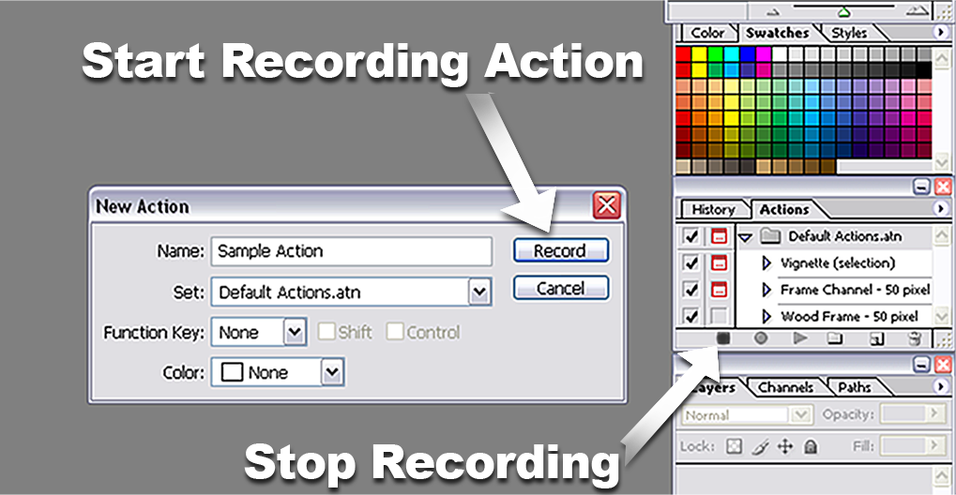

5 | Click on “Record.” | The dialog will disappear and every procedure or function you perform will be recorded in the order you do it and with the settings you create.

6 | When you have completed the process, click on the square “Stop” button at the bottom of the Actions Pallet. | This halts the recoding processes.
7 | To use the action either press the Function Key you assigned or open the Actions Pallet, scroll down to the proper action, highlight it, then click on the “Play” button which is the triangle ( ).

That’s all there is to it! And once the action is created you can assign it to a batch routine in the Automate menu to eun on several selected images files automatically.

