DIGITAL SPLIT TONING - Ver.1
N. David King

Split Toning is a fairly common darkroom technique to add a sense of depth and also a unique rendering to Black and White photographs. It is done by partially toning and image in one toner then completing it in another. Since most one-step toners work differentially, i.e. effecting the areas of greatest silver density first, the first toner generally has more effect on shadows and the second now can only respond to lighter areas. (Some toners work in the exact opposite manner so you will have to experiment with whatever brand of toner you have.)
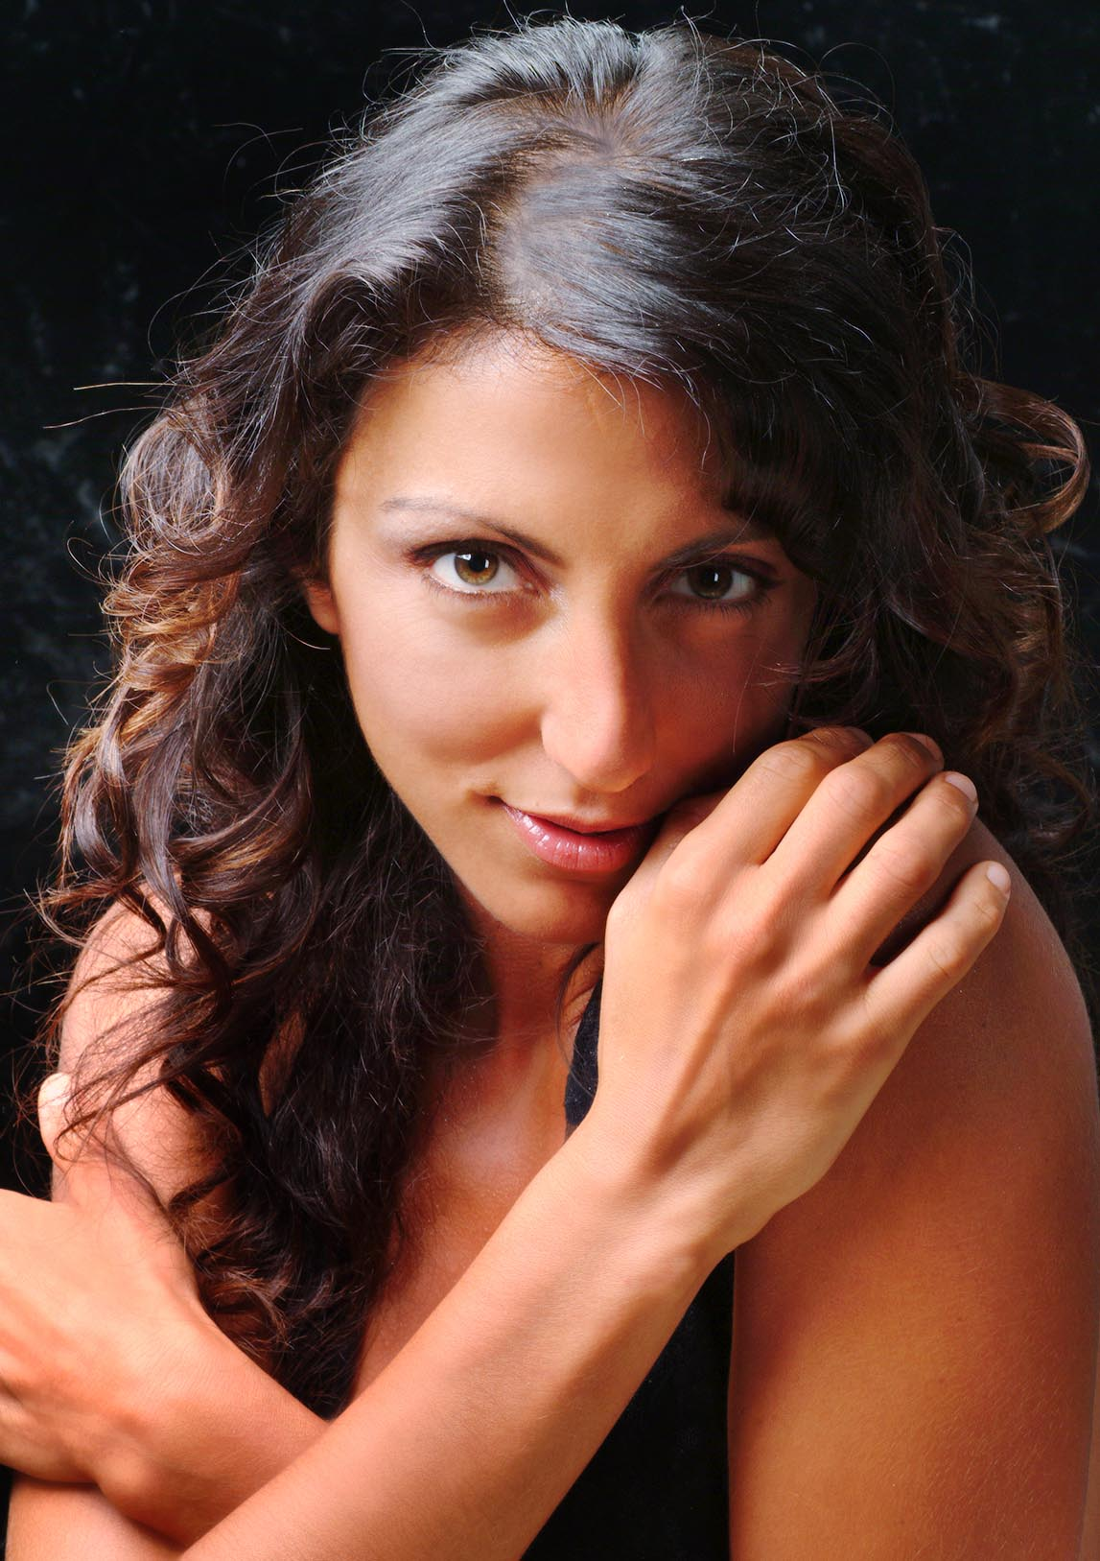
There are actually several ways to achieve a similar effect in the digital world. And, as might be expected, each technique yields a slightly different “look” to the photograph. Wow, just like using various brands and types of toners in the darkroom. Except here, once we like it, we can make endless exact duplicates…
We’ll start with one that is pretty close to the look of a wet darkroom print. However, the major advantage to doing it digitally is we have an infinite number of colors we can use and are not just limited to the standard ones.
For this demo I’ll use a shot done during a fashion shoot. Shot using a light red fill, the look is hot and smoldering but the normal image does not completely convey that. As is normally the case, we need to start by making a good “straight” version of the shot. Then take the following steps.

Step | Action | Result/Notes
1 | First we’ll convert the image to gray scale using the channel mixer.  ImageAdjustmentsChannel Mixer | Here I adjusted the channels to smooth out her skin tone.

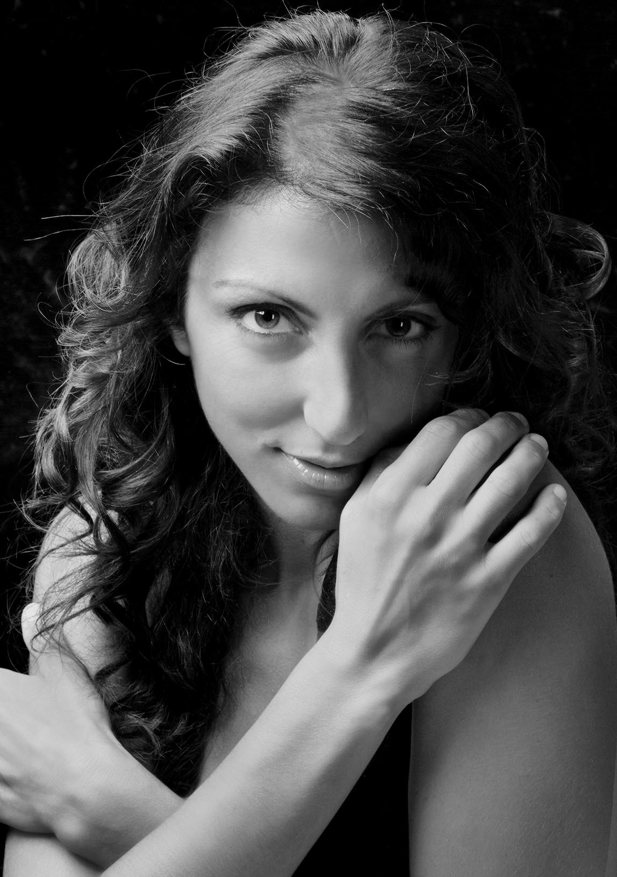
Figure 1 Grayscale version

 |  | The reddish tinge from the gel on the light actually created a problem with uneven color and I also had to do a little burning and dodging of this grayscale image to even it out. Do whatever is necessary to make the image work.
2 | Now we need to create two adjustment layers.
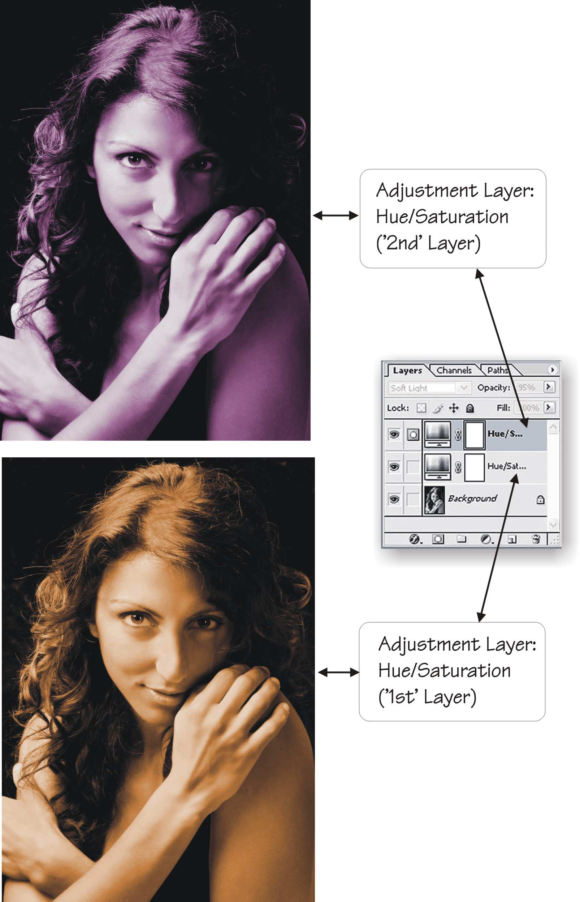

Because these two color layers will be blended it is helpful to have a knowledge of color and color mixing. You might be surprised at how these look when blended However you can always go back and play with the color of the layers to get it to look as you will want it.

3 | Work on the top layer. Open the Blending Options Dialog Box  LayersLayer StylesBlending Options  The key to splitting the effect is using the “Blend If” adjustments. | Here you can tell the program which tonal areas of each layer you want to blend, i.e. see through. Every image and specific effect may be different so you will need to play with them to get it just right.  You will also need to experiment with the blend “mode” (at the top of the blending options dialog). It defaults to “Normal” but here I used “Soft Light” to get the effect I was after.  Remember, this is an art not a science so you will have to do some experimenting to develop your own “look” for the shot.

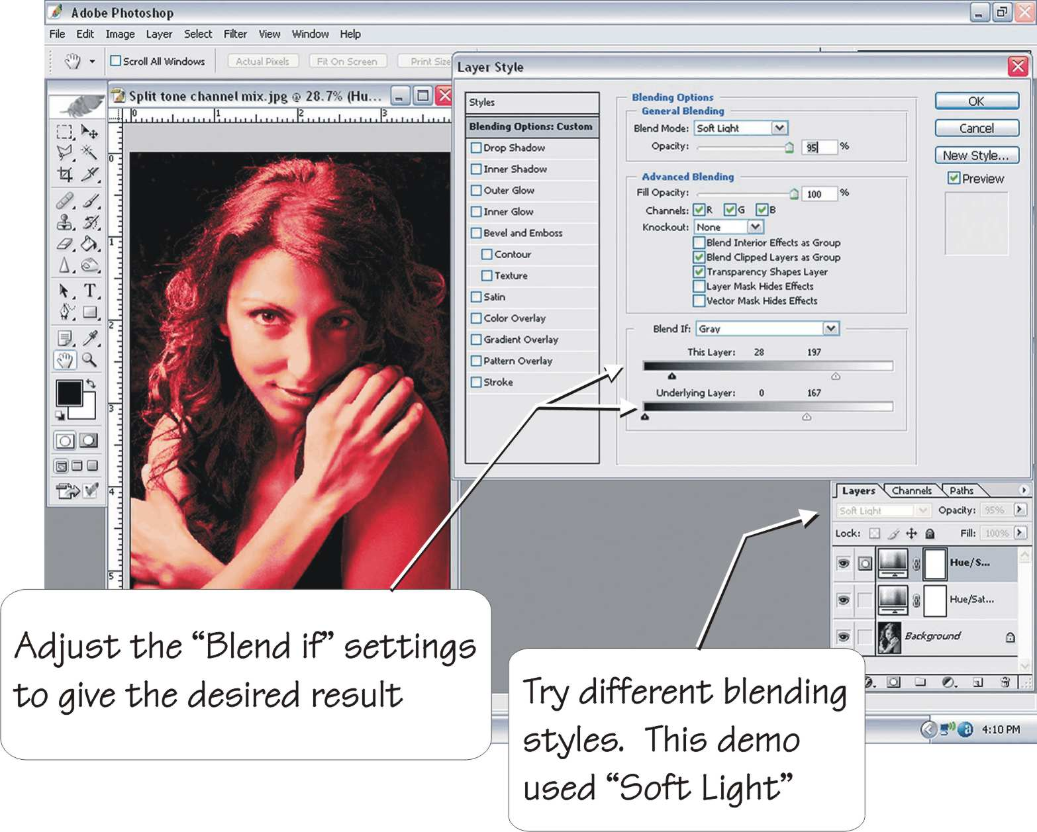

The settings shown in the Blending Options resulted in the next image.

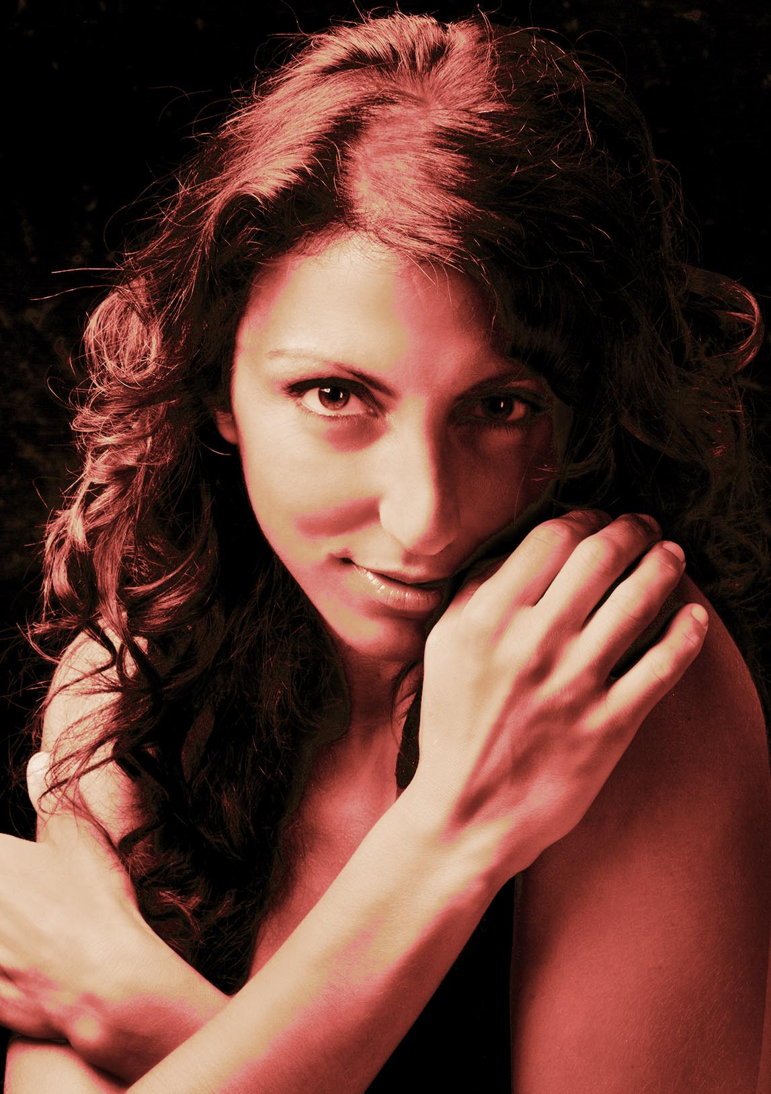
Figure 2 Split Tone "A"

 |  | This is not bad but I wanted to make it a little more dramatic and boost the heat a little. To accomplish that I added the next steps
4 | Select the background | I started with ‘Color Range’ and fine tuned it with the freeform selection brush.
5 | Using the eye-dropped I selected dark reddish and yellowish tones from the image to be foreground and background colors
6 | Using the gradient tool set to radial I then put a gradient into the background


Figure 3 Final version with gradient background

