Putting A “Watermark” on your Photo
N. David King

The internet has created an interesting problem. On the one hand it is the ideal way to let the world see your work. Unfortunately it is also the ideal way for unscrupulous individuals to steal your work. You want to put an image online that has sufficient resolution to display well but at the same time you want to lower its appeal for unauthorized use and minimize file size for faster opening. This is especially the case when you are putting proofs of work online for clients (such as wedding or event clients and also, sadly, sometimes for commercial clients) for easy selection but you are worried they will simply download the image and use it instead of paying you for it.

One solution many photographers have used is to “watermark” their online images with their name, logos, copyright notices, etc., or ANYTHING that will make the result unattractive to steal, difficult to edit out, and yet still show off the image for selection purposes. There are several ways to accomplish this, but here is a relatively easy one and it works with all versions of Photoshop.

Step | Action | Result / Notes
1 | Create your “watermark” and save it to its own file. | For this tutorial I’ll make a simple watermark using the Copyright Symbol but you can use anything you would like. You can make this in Photoshop or any graphics editing program but save it in a standard format such as TIFF or JPG.

2 | If this symbol will ONLY be used as a watermark then create it with a white symbol on a black background. | You can reverse the image later if this file might be used for other purposes, but this simply saves a step if it exclusively for watermarking your proofs.
3 | When you want to watermark an image. Open that image in Photoshop and then open the watermark file. | This will open the watermark file last and make it the active file.
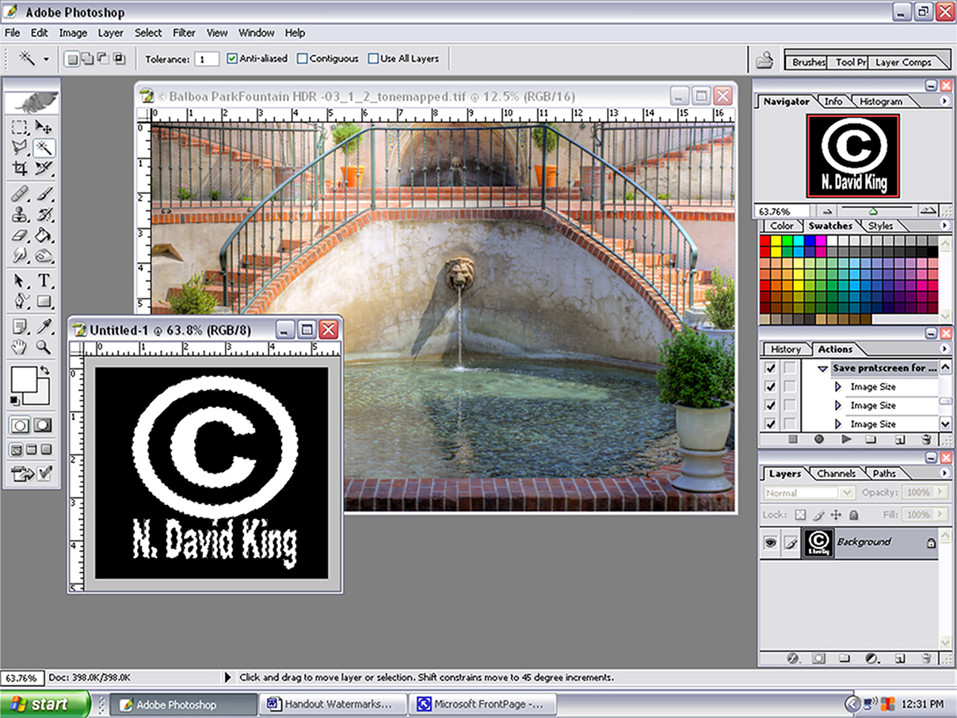
4 | Select the Symbol portion of the watermark file | You can use the Magic Lasso or the Color Section function. Just be sure you are selecting the symbol/text and not the background.
5 | Click and Drag the selection over to the image you want to watermark.

6 | Position then size, shape, this selection using the  EditTransformScale function. | To automate the process for an action pre-size the watermark file and save as a special named file. You can delete it later.
7 | Adjust Opacity of this watermark layer to taste. | You should be able to see it but just barely. If it covers intricate detail it can be a nightmare to try to edit out.
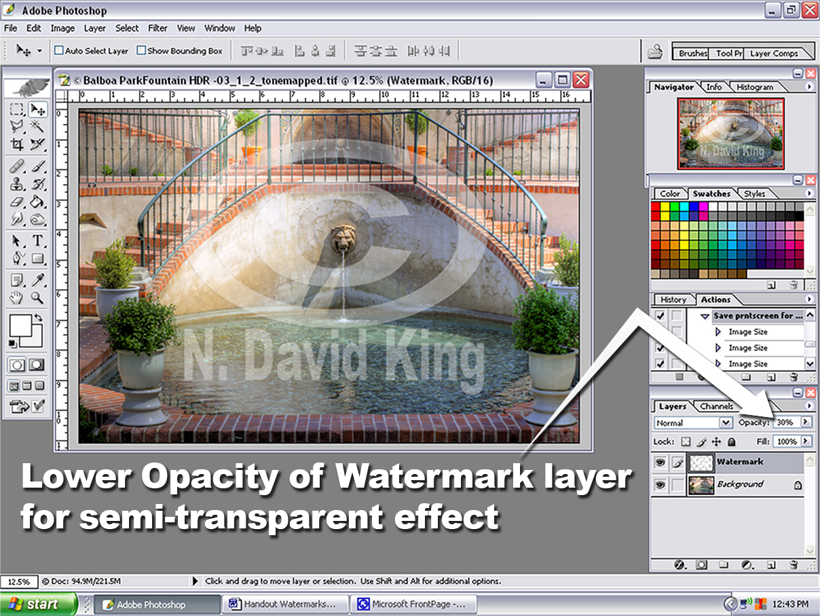
8 | You can also apply layer effects such as bevels, drop shadows, etc to make the watermark stand out more and to make it more complex and therefore more difficult to edit out.
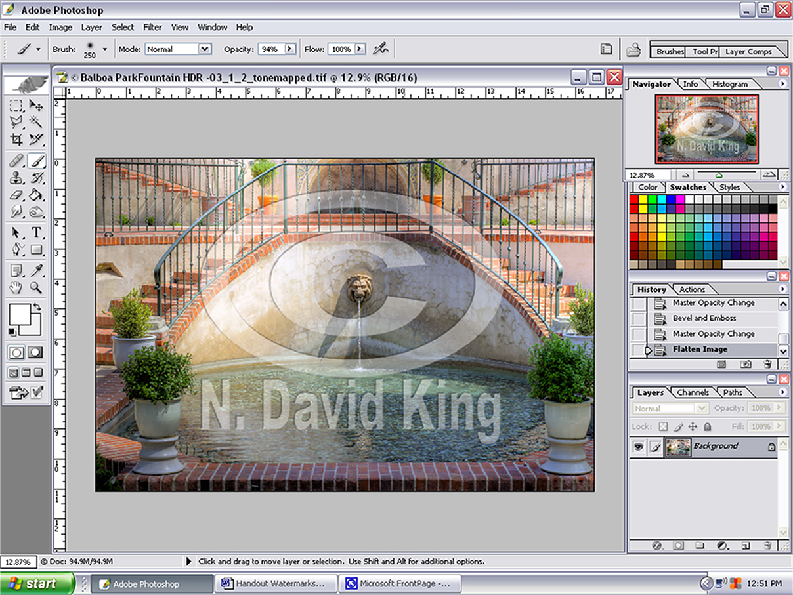
9 | Flatten and then save this file as a watermarked or proof file so you do not overwrite the master edited file.

If you have a number of image files to watermark, you can create an ‘action’ and apply it to them as you make adjustments. Or, through the Browser or Bridge you can apply it to selected files automatically.

