SENSOR CLEANING For DIGITAL SLRS
N. David King

One day you notice them. Like something out of a 1950s sci-fi movie about giant protozoa from space, these dark amorphous shapes start appearing in your images, first in the skies and other clear areas and then you can see them in areas of detail. Oh no, it’s sensor snot on your photos. Well, no, not exactly. It is usually dust or nearly microscopic dust bunnies of lint, dirt, hair, and other stuff you really don’t want to know about.

Dust is insidious. No matter how careful you are, if you change lenses on your DSLR, sooner or later it will get dust into the sensor chamber and onto the filters and/or microlens that are over the sensor. Go ahead, take all the care you want: only change lenses in a hermetically sealed clean room if you like. Yet somehow, by black magic I assume, the filthy little beggars will find a way to get inside your camera and while there, I’m convinced, breed into little dustettes. Dust bunnies are just like real bunnies in that regard. The results will show up as darkened spots on your files, most noticeably in areas of otherwise smooth tone such as skies. Generally it can be edited out but it is a pain and time consuming and, in the end, a pointless task since the solution is so easy. And a dark area slimed by sensor snot that crosses fine detail will keep you up at night trying to retouch it. It is definitely time to do something to get rid of it.

And now you are faced with a decision: most camera repair places will more than happily clean the sensor for you at a cost (at least around here) of about $50.00 per cleaning. Or, do you risk trying to do it yourself? Well, I’ve good news for you. YOU CAN DO IT!

It is pretty easy to keep a sensor clean if you stay on top of it. But if you let it get and stay dirty, the same grease that coats the inside of your car’s windshield will sooner or later coat the sensor and the dust and dirt will not longer succumb to easy cleaning and it may get so bad that now you really DO have to take it to the store for cleaning.

So here is a summary of the cleaning process. Remember, you are NOT cleaning the actual surface of the sensor array — that would indeed be a frightening thing to undertake. You are cleaning the surface of the top filter or microlens that covers the sensor. It is glass. It is incredibly thin (sometimes far thinner than a human hair), optically pure, and delicate. Think of it as being at least as fragile as the coating on your expensive lenses. It can easily and safely be cleaned if you do it correctly; but if you do it incorrectly then you can scratch or damage it and that will absolutely show up on your images and take a huge bite out of your pocketbook to have repaired. So simply learn to do it the right way or plan on spending lots of those $50.00 bills.

Test Frame

First, do a test frame. This is very easy. The most commonly prescribed way is to take a lens that is normal or slightly longer in focal length. Take it completely out of focus and aim it at the sky or some other smooth area and take an exposure using the cameras AE function. The result should be a smooth mid gray tone. Either zoom in on the camera monitor or bring it into your photo editor and zoom in to 300% or higher and then scan back and forth across the image. Sensor filth will show up as darker spots. If there are none then you are one lucky photographer. Go ahead and get the supplies below since sooner or later you will be needing them but make sure the camera body, lens, and mirror chamber are clean and pack it up ready for your next shoot.

But in the far more likely outcome that you see one or more of these ugly spots, it is time to clean it. Darn. Remember that the mirror and prism straighten and reorient the image so you see it correctly in the viewfinder. But it is recorded upside down and backwards on the chip. That means if you look at the image and see lint in the upper left then it will be in the lower right on the sensor.

OK, so it needs cleaning. What a surprise. First I’ll give you a list of supplies and some important information about their use and why one thing is better than another. Then when you have those ready we’ll get into the nitty-gritty of actually cleaning the sensor and while we are at it, the camera and lens too.

OK… Let’s Do It!

SUPPLIES

Before you start, make sure you have all of the supplies needed in front of you and handy. Here is a list to get and have ready. Then we’ll talk about them in detail. Please read that detail information before you rush out to buy stuff.

- Canned Air
- A good hand blower such as the Giotto™ Rocket Blower.
- Lint Free Pads or Wipes such as PEC™ Pads or KimWipes™.
- A soft nylon flat brush about ½” wide (see note below).
- A normal, slightly stiffer brush (for the camera body).
- High grade optical cleaner such as Eclipse™ brand.
- Sensor Swabs to fit YOUR sensor.
- Have the end caps for your lens ready to put on if it is on the camera.

On the next page is a photo of my own “cleaning kit” and the miniature medical bag I keep it in so it is always handy and together.

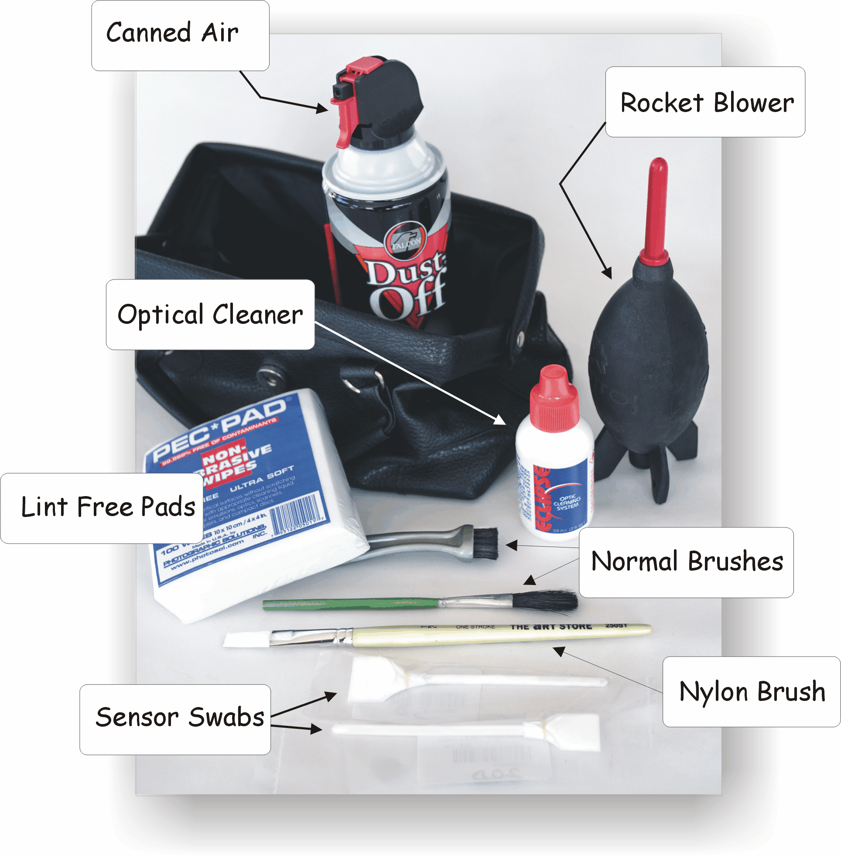
OK, let’s take a look at each item individually.

Canned Air
The canned air will be used to blow of dust from the outside of the camera and lens but not used anywhere inside. It will also be used to “charge” the nylon brush. Canned air is a good news-bad news product. It is extremely handy and useful but it is also dangerous to you and your camera if misused.

The suddenly released, decompressed air is freezing cold and can freeze skin. And it is powerful enough to blast shutters and mirrors out of cameras or imbed hard grit into lens coatings. Yet, used properly and with care it can clean items quickly and efficiently.

So when you use it, do it carefully and only as described in the procedures below. Never aim it directly at a delicate surface but always at an angle and from several inches away.

If the can has gotten shaken or fallen over, set it upright and let it sit quietly for 5-10 minutes before using it. This will prevent propellant from coming out in globs and welding itself to sensitive camera parts.

Rocket Blower
The blower will be used to blow loose dust out of the mirror and sensor chambers and off of the surfaces of the lens. You need a good stream of air. The old grey colored “blower brushes” were and are a waste of money except for the nice soft brush. Giotto™ makes a black rubber squeeze blower that looks like a Buck Rogers spaceship. Especially the large one is very good and really provides some reasonable air flow for the delicate parts of the camera.

Lint Free Pads
PEC™ Pads and Kimwipes™ are wonderful lint free pads to clean glass surfaces. Some cheap so-called “lens tissue” is NOT lint free and will leave streaks and tiny particles on a lens, especially if you get it overly wet. Lens tissue residue on a lens surface is so small that you may never notice in a shot or even on an enlarged negative; but if you leave even a tiny strand of lint over the sensor you will instantly see it in the photograph as HUGE.

Nylon Brush
This is the key to the whole operation. This brush MUST be nylon. If you get it at the art store you can get ones that are white and others that are dyed to look like normal animal hair brushes. I like white since I can easily tell when it needs cleaning but both work. You can also get nylon brushes at the makeup counter but they are more expensive.

Art store brushes are often shipped packed with an adhesive to protect the bristles. This must be cleaned off. However it is water soluble and easy to remove. Use dish washing soap, clean it thoroughly, rinse well and let air dry. To test how clean it is, brush hard against a mirror (or filter) to see if any streaks are left which would indicate residual adhesive and the need for more cleaning. These will look like tiny scratches abut are actually just adhesive and they clean right off. If it does not leave streaks and feels soft and pliable it is ready to use.

Now, here is why the nylon brush is so important to this process. When the bristles on a nylon brush rub against each other, they develop a static charge that will attract dust. This brush will allow you to remove light dust particles without scraping them around the surface as with a normal brush. Hold the nozzle or tube close to the brush and use the canned air to blow through the bristles for 3-5 seconds. It will remove any previous dirt and charge the bristles. Then lightly brush across delicate areas needing the dust removed. Only brush an area once then recharge the bristles with the canned air. This keeps you from moving girt around on the surface and creating little micro scratches.

As an alternative you can order one of the custom sensor cleaning brushes from visible dust (www.visibledust.com). They make extremely nice and extremely expensive sensor cleaning supplies. They also make a device that twirls the brush at high speeds to get rid of particles and recharge the bristles. There is nothing bad to say about them… except for the prices.

Normal Cleaning Brush(es)
You also need a normal brush or even a soft toothbrush that can be used to remove any dirt on the outside of the camera or lens body where the brush will not damage the surface. I have one fairly soft one and another with short bristles that is better at removing mud or caked on stuff from the camera body. I use it rarely but when needed it works fine.

I also keep a supply of Cotton swabs like Q-Tips™ to clean small complex areas though they are not in the picture.

Optical Cleaner for Sensor and Lenses
Do not use cheap lens cleaner. And do NOT use a harsh commercial product like Windex™ to clean your lenses or especially your sensor. ANY streaking or residue is to be avoided at all costs as are solvents that will remove coatings. The Eclipse™ brand cleaner I use is comparatively expensive but does not streak and cleans really well. You can get it at most camera stores. The Visible Dust cleaner is also excellent.

Sensor Swabs
The sensor swabs are used ONCE and thrown away. You should get them specifically to fit YOUR camera’s sensor since they are used to make ONE swipe across the sensor in each direction and then are to be thrown away rather than risking wiping grit back and forth across the delicate glass filters or microlens. These are expensive but if you keep your camera clean you may not have to use one every time you clean it. Once you have used a real one you can make your own out of the core of the actual ones and a layer of the PEC pads.

The ones made by Eclipse and Visible Dust are excellent but there are other good ones as well.

THE PROCEDURE

It is counter productive to clean the inner parts of the camera and then let dirt that was on the outside fall back into it. To avoid that ‘dirtying’ a clean area, clean the whole camera starting with the body, then the lens, then proceed inside to the mirror chamber and finally to the sensor chamber. For each part you will proceed in essentially the same fashion from the least physically agressive and intrusive to more aggressive approaches as, but only as, needed. OK, cleaning supplies at the ready? Here we go…

- Clean the body of the camera
  - Use the canned air to carefully blow off any surface dust you find.
  - Use the normal brush or toothbrush to brush away any stubborn areas.
  - If something remains, use a damp, soft cloth to wipe down the body.

- Clean the lens
  - Remove the lens from the camera and have the front and rear caps handy.
  - Use the canned air to carefully blow away surface dust from the lens barrel. Do not use it on the glass.
  - Use the rocket blower to blow away dust that is on the surface of the lens. Especially pay attention to the filter threads and other complex surfaces where dust can collect.
When blowing out the rear of a lens with a recessed rear element, hold the lens with the rear facing downward so that loosened dust can fall out of the area.
  - Use the normal brush on the barrel and around the threads or other non-glass parts if the blower did not remove it.
  - If the blower did not remove all the particles from the glass, use the nylon brush. Charge it and brush lightly across the surface.
  - If that does not remove grease or oil or grit stuck in that, then you will have to use a liquid cleaner. Put a drop of the cleaner on the lint-free pad and, starting from the center, clean outward in a spiral. The pad only needs to be damp, it does not have to be soaking wet.
Use a VERY light touch and do not scrape any serious grit further. If it comes free, move to a clean area of the pad and start over from the center.
  - Good optical cleaners will not streak unless you have used way too much on the pad. If you do leave streaks, use a clean dry pad to remove them before they dry on the surface. Do NOT try to “polish” the lens; you will only succeed in removing the coating.
  - As you finish with each end of the lens put the cap on it to keep it clean.

- Clean The Inside of the Camera – First the Mirror Chamber
  - Follow the same sequence. Use the rocket blower to blow out the mirror chamber. Remember to hold the camera with the opening facing down so the dust will simply fall out instead of resettling back into place.
  - The mirror itself is a challenge because unlike personal mirrors, this one usually has the silvering on the outside not on the back. That gives it much higher reflective qualities but makes it much more vulnerable to any solvents or abrasives that can remove the silvering. So be very careful and have a very light touch here.
  - If the blowing did not remove everything use the charged nylon brush to softly wipe across the surface. This can be good practice for the sensor coming up.
  - If materials still cling to it then use a PEC pad or KimWipe just dampened with the optical cleaner. Do NOT soak the mirror or let any drop or puddle of cleaner sit on it. It can attack the silvering.
  - While you’re in here, blow, brush, and clean the bottom of the pentaprism too. It will be visible on the roof of the mirror chamber. If you see any dirt in the viewfinder it has to be either on the mirror or on the base of the prism so now is the time to get rid of it.

- Clean the Sensor
OK, here comes the serious part…
- READ YOUR CAMERA MANUAL. Be sure you know how to open and lock open the mirror. It is slightly different for different brands and models of camera. Some have a cleaning option. On Canons make sure the mode is set to “manual” or you cannot access this. Others make you lock open the mirror as a shutter setting function for long exposures.
- Make sure you have a fresh battery installed or are using AC power to the camera. Only this power sources is holding the mirror open and you do not want it to fail and slam the mirror shut on your brush or swab and ram those into the sensor.
- OK, this is it… no more delays or stalls… open the mirror. Inside you will be staring at the sensor. It looks smooth and shiny but that is an illusion due to the incredibly small photo sensors. First take the rocket blower and with the camera inverted (opening toward the floor) blow out the area. Make sure you blow all around and across the sensor but do NOT hit the sensor with the nozzle of the blower. And do not even THINK about using the canned air for this step.
If you have been keeping your camera clean this may be all you need to do. Fire a quick test shot and examine it closely. If it is clean you can stop here. If not, go to the next step.
- Charge the brush and wipe in lightly across the sensor. If the sensor is bigger than the brush then after a swipe, recharge it and do the remaining part. Look at the sensor. You will see large objects like hairs or lint. If there are some, brush it again following the same “charge-swipe-recharge” technique. Look again. If it looks clean (you can order special sensor scopes to check it out very closely) you might want to shoot another test frame to be sure. But since it is open and this might be your first time to clean it really well, let’s move on to the final step.
- Remove a swab from its plastic bag and put a drop (only a drop) of the optical cleaner on each side near the tip. Place the swab squarely on one end of the sensor (1) at as low an angle as possible then sweep it lightly across the sensor, straightening it up as you go so that when you reach the other side the brush will be nearly vertical (2).
This rocking motion continually places clean pad surface on the sensor.
Now rock the swab over (3) and repeat the sweep in the opposite direction using the other side of the swab(4). When you finish this reverse sweep you can throw this swab away, but do not use it on the sensor again.
Unless you can see visible material still on the sensor, it is time for another test shot (as described above). You do not want to be touching the sensor area any more than necessary. If specks still show up in your test then open the mirror and repeat until they are gone.
- KEEP IT CLEAN!!! Put all caps back on and replace camera in your case ready for the next shoot. I keep the bodies and lenses in my case in plastic bags when on shoots to try to keep the dust or grit to an absolute minimum. If you have a sealed case be sure and keep some dessicant in it to absorb any moisture from humidity or condensation or that was not wiped off from a camera or lens that got wet.

