The Digital “Orton Effect”
N. David King

Photographer Michael Orton along with Freeman Paterson and others used this effect to create a dreamy image that was somehow soft and glowing yet had crisp edges. Because Orton was the first to publish it in consumer photo magazines, it became known as “The Orton Effect.” It resulted in an impressionistic yet not quite pictorialist style photograph. Originally it was done with slide film.
To accomplish the effect, two images were shot from a tripod. The first was sharp and over exposed by one half to one stop. The second shot was thrown out of focus and overexposed by two stops. When the two were sandwiched together in registration, the resulting densities were slightly light yet you had the sharpness of one and the softness of the other. Experimentation was done with various special effects filters for the second shot or using motion blur. Some portraits were done this way but they required a model that did not move during the time required for the two exposures. Of course not every shot worked; different subjects and “visions” require the appropriate approach to best render them rather than trying to shoehorn every shot into a preconceived “look.” The ones that did work well, however, were often stunning.
This effect can be duplicated in Photoshop in several ways and, especially if shooting RAW, using the converter to create the two “exposures” from the original file creates a much closer rendition to what was accomplished with film. And, it means, it can be done with moving objects since only one actual exposure needs to be taken and time is no longer an issue.
Here are a couple of variations in creating the effect.

Open your image (Image 1)
- Duplicate the background layer (Right click on the background layer and choose duplicate) and name that layer Sharp
- Create another duplicate of the background layer.
- Change the Blending mode of the Sharp Copy to screen
- With the Sharp Copy layer selected, right click and choose Merge Down (Image 2)
- Right click on the Sharp layer, choose Duplicate and name this layer Out of Focus
- On the Filter Menu, choose Blur - Gaussian Blur (Image 3)
Depending on the resolution of the image you are using, the amount of blur needed will change. Use enough that the shapes are still visible, but detail is not. For this 6.1 Megapixel image, a value of 15.9 was sufficient.
- Change the blending mode of the Out Of Focus layer to Multiply. (Image 4)
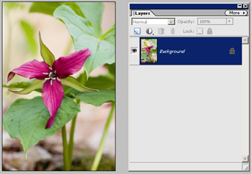
Image 1
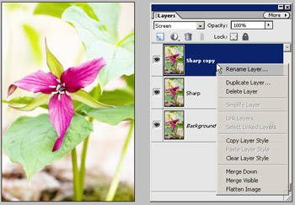
Image 2
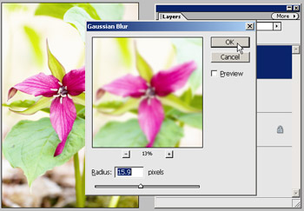
Image 3
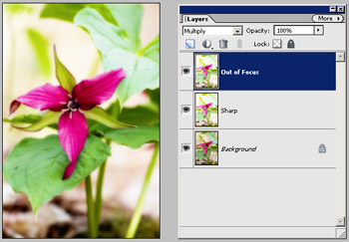
Image 4
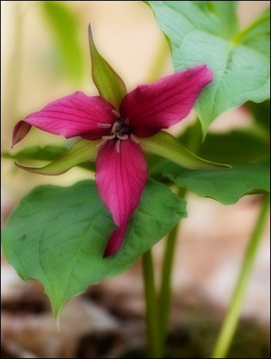
Final image including levels adjustment and cropping
Once you are complete, you may find it necessary to adjust the opacity of your Out of Focus layer and/or apply a levels (or curves) adjustment layer to the Sharp layer if some tweaking is necessary.You can also adjust the amount of blur you apply to the out of focus image, as well as adjustments such as level, brightness and contrast and it is good practice to apply sharpening to your image Sharp layer. (Image 5)

Orton Effect Version 2
Here is a second take on it courtesy of (Garry Black (www.garryblack.com)
- Make a copy of your original image (Image  Duplicate).
- Apply Image (Image  Apply) and set blending mode to “Screen” and Opacity to 100%
- Make duplicate Layer (Layers  Duplicate Layer) Blending mode to “Multily”
- Activate the “Background Copy” layer and blur image (Guassian Blur) of 10-40 px
- Flatten and Save

Options
You can also play with a number of options to create the image. You can use curves on the second image to “overexpose” the mid tones but leave dark lines and edges. You can also use filters other than or in addition to the Guassian Blur such as motion blur, etc.
Again, this is not something that saves bad images or can be used on every image. But if your vision for the shot was a more “dreamy” look, this might be just the answer you were looking for.

